***Rhizomucor miehei* protease (RMP) = *Positive Control***

C:\Users\dell\Desktop\Others Papers\Shilan\Manuscript\Figs\Fig.3.tif

**Fig 1.** Site-specific molecular docking. Demonstration of 2D interactions between RMP protease and κ-casein at which the hydrogen bond forming residues are highlighted in green color

**C:\Users\dell\Desktop\Others Papers\Shilan\Manuscript\Figs\Fig.4.tif**

Fig 2. MD analyses of RMP at different temperatures. **(A)** Plotted RMSD. **(B)** Plotted SASA values. **(C)** Plotted Rg values. **(D)** Plotted number of H-bonds.

**Table1.** The average values of RMSD, SASA, H-bonds and Rg of the RMP at different temperatures.

|  |  |  |  |  |
| --- | --- | --- | --- | --- |
| **Temperature** | **RMSD (nm)** | **SASA (nm2)** | **H-bond** | **Rg (nm)** |
| **30 °C** | 0.1658 ± 0.098 | 154.589 ± 3.8 | 265.251 ± 7.39 | 2.040 ± 0.136 |
| **40 °C** | 0.1725 ± 0.035 | 155.0931 ± 4.56 | 261.640 ± 11.53 | 2.042 ± 0.237 |
| **45 °C** | 0.1604 ± 0.067 | 154.380 ± 7.26 | 267.445 ± 9.67 | 2.037 ± 0.185 |
| **50 °C** | 0.1925 ± 0.073 | 156.833 ± 5.67 | 260.694 ± 13.89 | 2.043 ± 0.214 |
| **60 °C** | 0.2204 ± 0.032 | 158.179 ± 3.98 | 257.825 ± 12.93 | 2.044 ± 0.397 |

C:\Users\dell\Desktop\Others Papers\Shilan\Manuscript\Figs\Fig.5.tif

**Fig 3.** Plotted RMSF of RMP protease (2ASI) at different temperatures

**Table 2.** The average numbers of RMSF values at different temperatures for WT protease (2ASI)

|  |  |  |  |  |  |
| --- | --- | --- | --- | --- | --- |
| **Temperatures** | **30 °C** | **40 °C** | **45 °C** | **50 °C** | **60 °C** |
| **RMSF (nm)** | 0.099698 ± 0.011 | 0.106492 ± 0.037 | 0.098402 ± 0.0128 | 0.116641 ± 0.0253 | 0.12019 ± 0.028 |

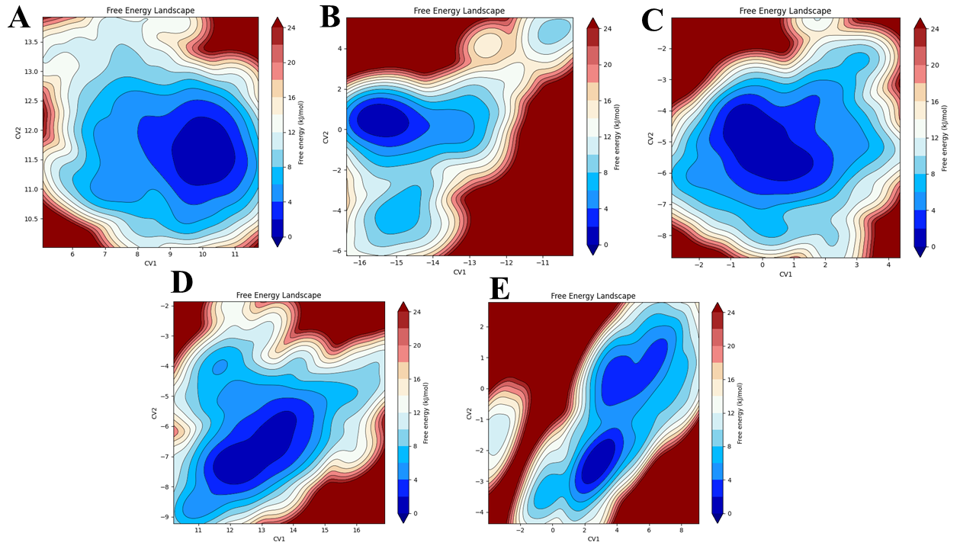

**Fig 4.** Free energy landscape (FEL) analyses of RMP protease (2ASI). **(A)** 30 °C **(B)** 40 °C **(C)** 45 °C **(D)** 50 °C **(E)** 60 °C.

C:\Users\dell\Desktop\Others Papers\Shilan\Manuscript\Figs\Fig.7.tif

**Fig 5.** Principal component analysis (PCA) of WT protease (2ASI). **(A)** 30 °C **(B)** 40 °C **(C)** 45 °C **(D)** 50 °C **(E)** 60 °C.

**Table 3.** MM-PBSA values of RMP at different temperatures

|  |  |  |  |  |  |
| --- | --- | --- | --- | --- | --- |
| **RMP (2ASI)** | | | | | |
| **Temperatures** | **30** °C | **40** °C | **45** °C | **50** °C | **60** °C |
| **MM-PBSA (*kcal*/*mol)*** | -20.34 | -27.35 | -33.9 | -31.33 | -29.21 |

**Negative control:**  was selected as peptide with low predicted affinity for Pepstatin A based on machine learning

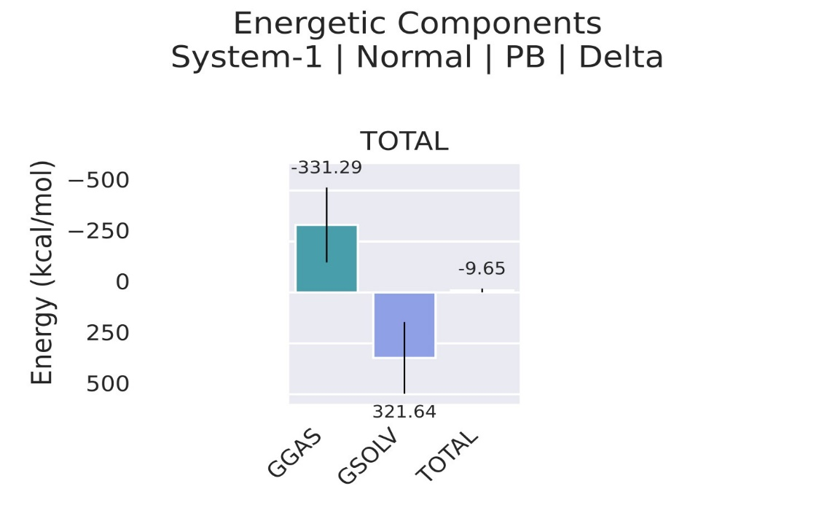

**Fig 6. MMPBSA of negative control is -9.65 (kcal*/*mol)**